附件2：
预估维修面积
仓号 | 仓房四周缝 |  |  |  | 顶板伸缩缝 |  | 合计
仓号 | 东南 | 西南 | 西北 | 东北 | 条 | 伸缩缝面积
军P1 | 4m*0.3m  =1.2m2 | 4m*0.3m  =1.2m2 | 6m*0.3m  =1.8m2 | 2m*0.3m  =0.6m2 | 2 | 23.41m*0.3m*2  =14.046m2 | 18.84m2
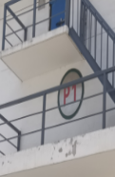 | 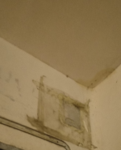 | 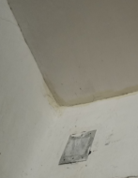 | 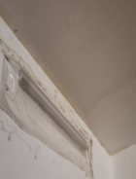 | 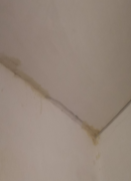 | 2 | 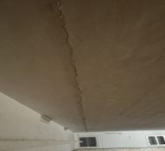 | 18.84m2
军P2 | 7m*0.3m  =2.1m2 | 13m*0.3m  =3.9m2 | 13m*0.3m  =3.9m2 | 4m*0.3m  =1.2m2 | 3 | 23.41m*0.3m*3  =21.07m2 | 32.17  m2
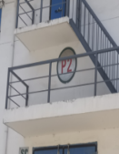 | 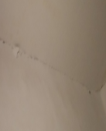 | 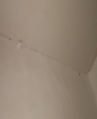 | 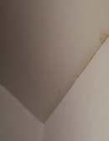 | 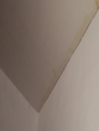 | 3 | 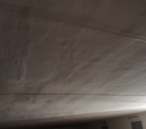 | 32.17  m2
P59 | 27m*0.3m  =8.1m2 | 30m*0.3m  =9m2 | 30m*0.3m  =9m2 | 26m*0.3m  =7.8m2 | 6 | 23.41m*0.3m*6  =42.14m2 | 76.04m2
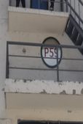 | 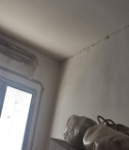 | 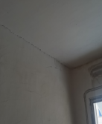 | 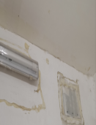 |  | 6 | 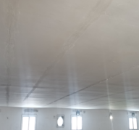 | 76.04m2
P61 | 33m*0.3m  =9.9m2 | 33m*0.3m  =9.9m2 | 33m*0.3m  =9.9m2 | 33m*0.3m  =9.9m2 | 11 | 23.41m*0.3m*12  =84.28m2 | 123.9m2
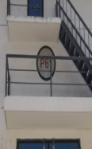 | 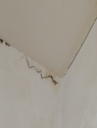 | 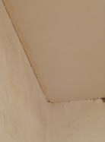 |  | 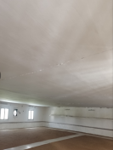 | 11 | 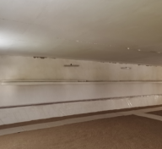 | 123.9m2
合计面积 |  |  |  |  |  |  | 251m2

